SCHOOL NAME: __________________________ EXAMINATION NO: ______________

SOUTH EAST EDUCATION DIVISION
2025 MALAWI SCHOOL CERTIFICATE OF EDUCATION MOCK EXAMINATION

MATHEMATICS

Subject Number: M131/II
Friday, 28th March Time Allowed: 2 hrs 30 min
8:00 – 10:30 am

PAPER II

THEORY
(100 marks)

Instructions
- This paper contains 12 printed pages. Please check.
Question number | Tick if answered | Do not write in these columns
- Answer all six questions in section A and any four questions in Section B.
- The maximum number of marks for each answer is indicated against each question.
- Scientific calculators may be used.
- All working must be clearly shown.
- The graph paper and blank answer sheet at the end of the question paper can be used if required. Do not tear the off.
- All working must be clearly shown
- Write your examination number on top of each page of the question paper
- In the table provided on this page, tick against the question number you have answered.
- Hand in your filled questions paper to the invigilator when time is called to stop writing

© 2025 SEED MOCK Turn over/…
Section A (55 marks)
Answer all the six questions in this section in the spaces provided.
- (a) Simplify - (4marks)

(b) Without using a calculator, simplify , leaving the answer with a rational
denominator.
(4marks)

- (a) Solve for y in the equation + = 4. (6marks)

Continued/…

(b) Factorise 2 – 4x + 3 (5marks)

- (a) Figure 1 shows a quadrilateral ABCD in which = 3d , = e , and d .

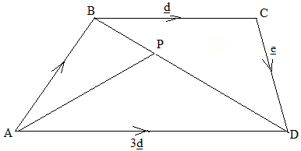
Figure 1
Given that = BD, find in terms of d and (7 marks)

Continued/…
(b) The fee per student at Masambuka University varies partly to the number of students
in a class and partly inversely to the number of lessons. The fee per student for 5 lessons with a class of 20 is K6000 and for 8 lessons for a class of 50 is K12000. Find the fee for 5 lessons with a class of 8. (6marks)

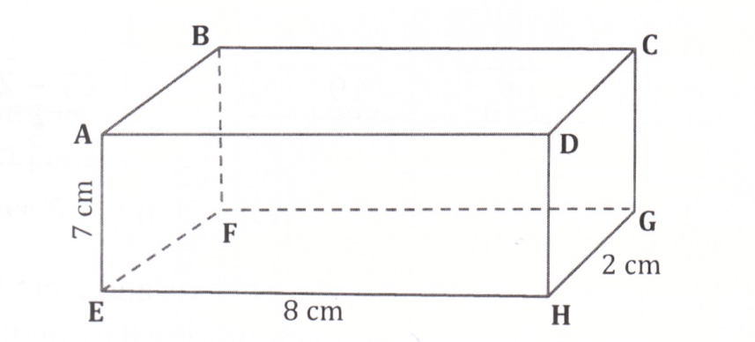
4. (a) Figure 2 is a cuboid ABCDEFGH in which AE= 7cm , EH = 8cm and HG = 2cm .

Figure 2
Calculate the value of the angle between BH and the plane ABCD, giving the answer correct to three significant figures. (5marks)

Continued/…
(b) Using a pair of compasses and a ruler only , construct in the same diagram :
i. a circle centre O of radius 4cm.
ii. two tangents AT and BT from an external point T such that OT = 10cm.
iii. measure and state the value of angle OTB. (6marks)

5. (a) Figure 3 shows a circle ABCD centre O. Angle AOC = and angle BAC =
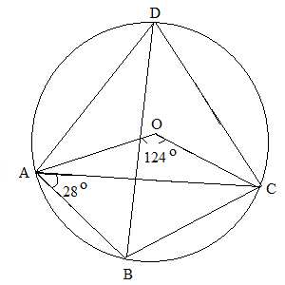
Figure 3
Calculate the size of angle BCA. (5marks)

Continued/…
(b) Solve the equation = . (4marks)

- The times in minutes taken by 30 students to complete a class project are given in
the table below.
47 | 61 | 53 | 43 | 46 | 46
68 | 48 | 72 | 57 | 48 | 54
41 | 63 | 49 | 42 | 38 | 65
45 | 44 | 43 | 51 | 45 | 38
48 | 46 | 44 | 52 | 43 | 47
(a) Construct a frequency distribution table with classes starting from 35 – 39 , 40 – 44. (3marks)

(b) Draw a histogram of a grouped distribution and state the modal class. (5marks)

Continued/…
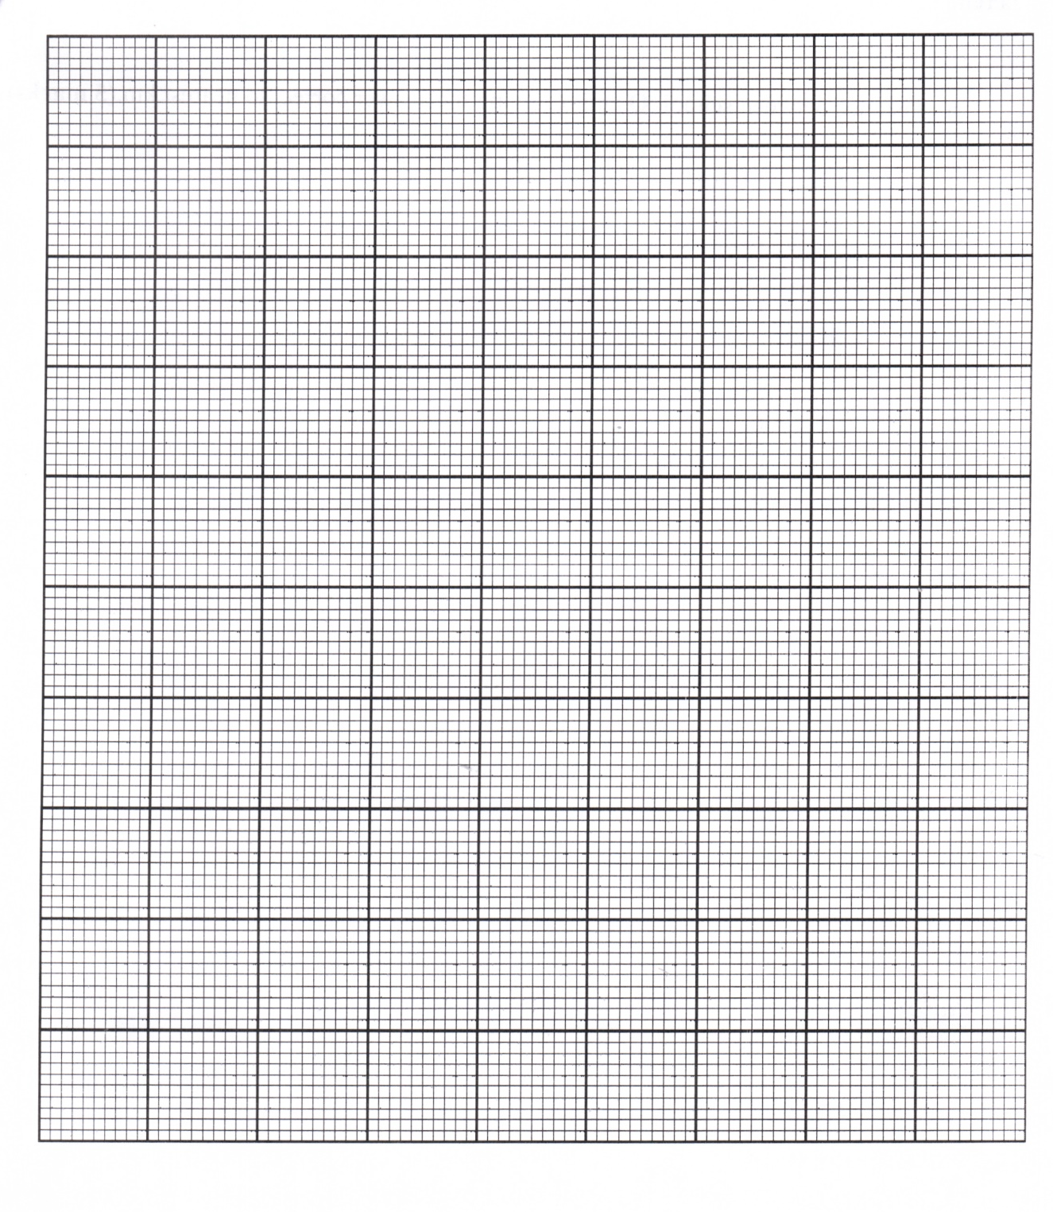
SECTION B (45 marks)
Answer any four questions from this section in the spaces provided.
7. The table below shows some values of x and y of the function y = 3 + 2x - .
x | -2 | -1 | 0 | 1 | 2 | 3 | 4
y | -5 |  | 3 | 4 |  | 0 | -5

(a) Complete the values of y in the table. (2marks)

Continued/…
(b) Using a scale of 2cm to represent 1 unit on the horizontal axis and 2cm to represent
2 units on the vertical axis , draw a graph of y = 3 + 2x - on the graph paper
provided. (5marks)
(c) Use the graph drawn in 7 (b) to solve the equation 0 = 6 + 2x - .
(3marks)

Continued/…
8. (a) Figure 4 is a tree diagram for the probabilities of the subcommittee that consists of 4 women and 6 men. A subcommittee of 3 people is formed from it.
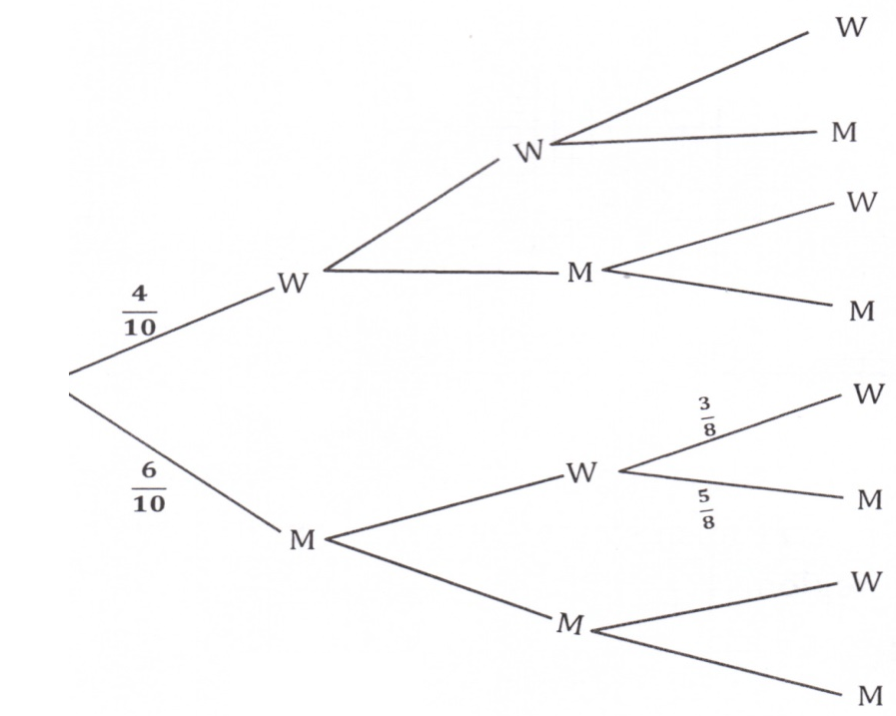
Figure 4
Complete the probabilities of each branch in the tree diagram in figure 4. (5marks )
(b) Use the tree diagram in (a) above to calculate the probability that two members of the
sub-committee are men. (5marks)

9. Solve the equation - 2 + = .
(10marks)

Continued/…
10. The first four terms of an arithmetic Progression (AP) are b, 2b + 1, 5b – 1 and 4b + 3.
(a). Calculate the value of b. (4 marks)

(b). Find the sum of the first 12 terms. (6 marks)

- The sum of the squares of the ages of the father and daughter is 964. Four years ago, the difference between their ages was 22. Calculate their present ages. (10marks)

Continued/…
12. Nthawi air lines uses two types of air buses, M and N. Type M air bus carries 200
passengers while type N carries 300 passengers per trip. There are more than 12000 to
be moved. The air buses are to make no more than 60 trips. Type N trucks are to make
at most twice the number of trips made by type M trucks.
- If x represents the number of trips made by type M air buses and Y the number of
trips made by type N air buses, write down three inequalities representing this information in addition to x0. (3marks)

(b) Using a scale of 2cm to represent 10 units on both horizontal and vertical axes, draw
on the same graph to show the region represented by the four inequalities by shading
the unwanted region. (5marks)
(c ) The air line makes a profit of 1 million Kwacha per trip on type M and 2 million
Kwacha per trip on type N. State the number of trips a company should make in order to maximize profit. (2marks)
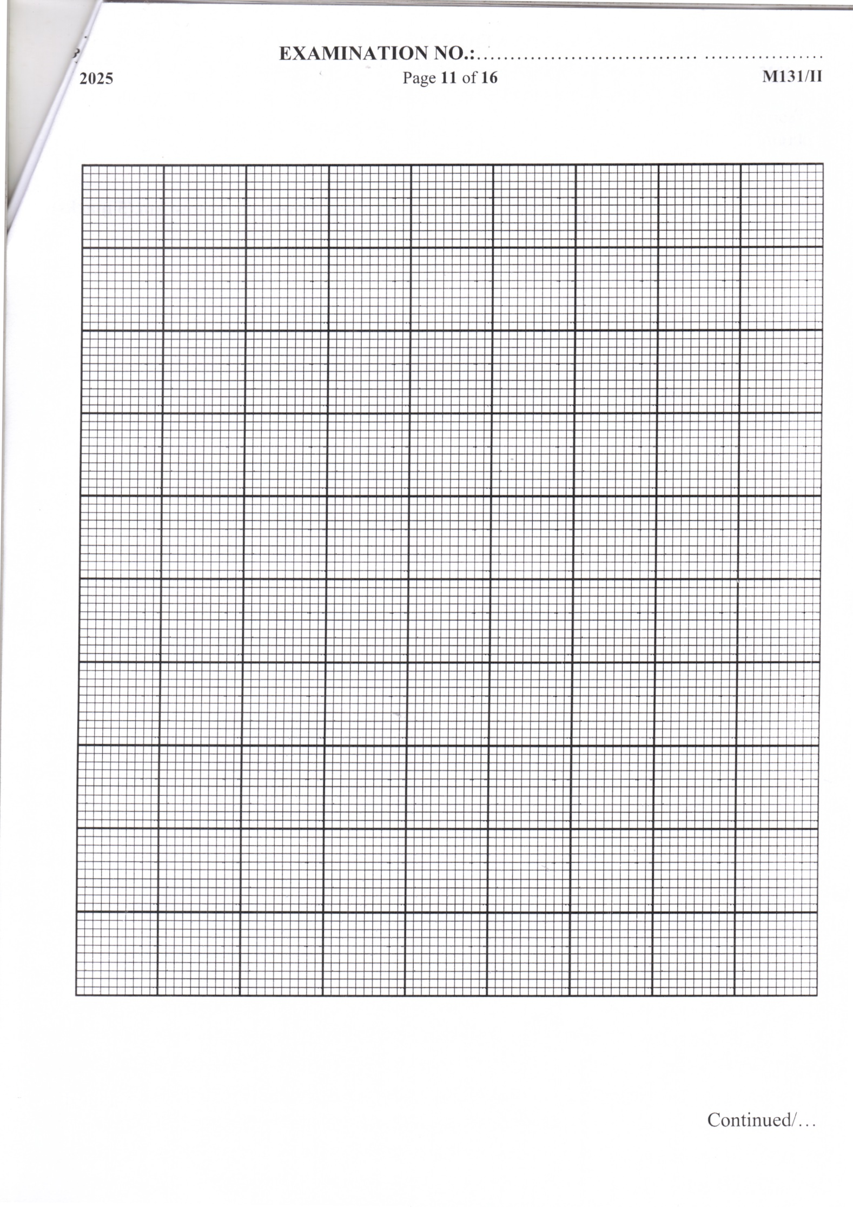
END OF QUESTION PAPER
NB: This paper contains 12 printed pages

